CHAPTER 10: Heat and electricity
Worksheet 10.3

Simple circuits
Science Quest 9: pages 358–60
Student: Class:

Circuit components
1. Complete the table by identifying the component or drawing the symbol for the named component.
Name | Symbol | Name | Symbol
Ammeter |  |  | 
 |  | Battery
 | 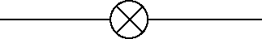 | Cell
Voltmeter |  |  | 

Drawing simple circuits
2. Use the symbols for the circuit components to draw the equivalent circuit for each example.
(a)  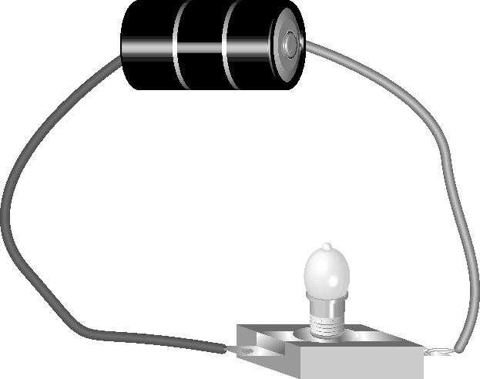 |  | (b)  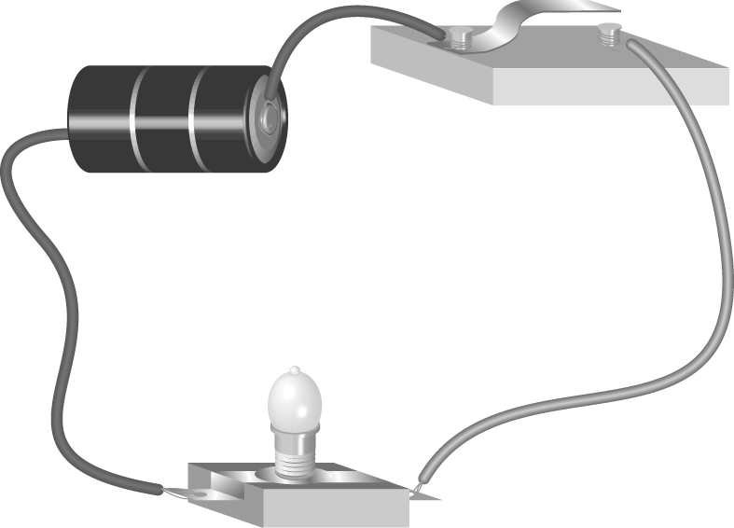

The torch circuit
3. Draw a circuit diagram to show how a torch works.
